Nama : Salsa Bila Naqiyyah

NIM : 21.01.55.0018

**DOKUMENTASI TUGAS WEB SERVICE DEVELOPMENT**

1. **Membuat Database Courses**

CREATE TABLE courses (

id INT AUTO_INCREMENT PRIMARY KEY,

title VARCHAR(255) NOT NULL,

instructor VARCHAR(255) NOT NULL,

duration INT NOT NULL,

price FLOAT (10, 2) NOT NULL

);

INSERT INTO courses (title, instructor, duration, price) VALUES

('Dasar-Dasar Basis Data', 'Dr. Budi Santoso', 40, 500000.00),

('Pengembangan Web Dasar', 'Ibu Siti Aminah', 60, 350000.00),

('Ilmu Data dengan Python', 'Dr. Ani Wulandari', 50, 750000.00),

('Pembelajaran Mesin untuk Pemula', 'Bapak Joko Widodo', 45, 600000.00),

('Keamanan Siber untuk Pemula', 'Ibu Rina Sari', 35, 450000.00);

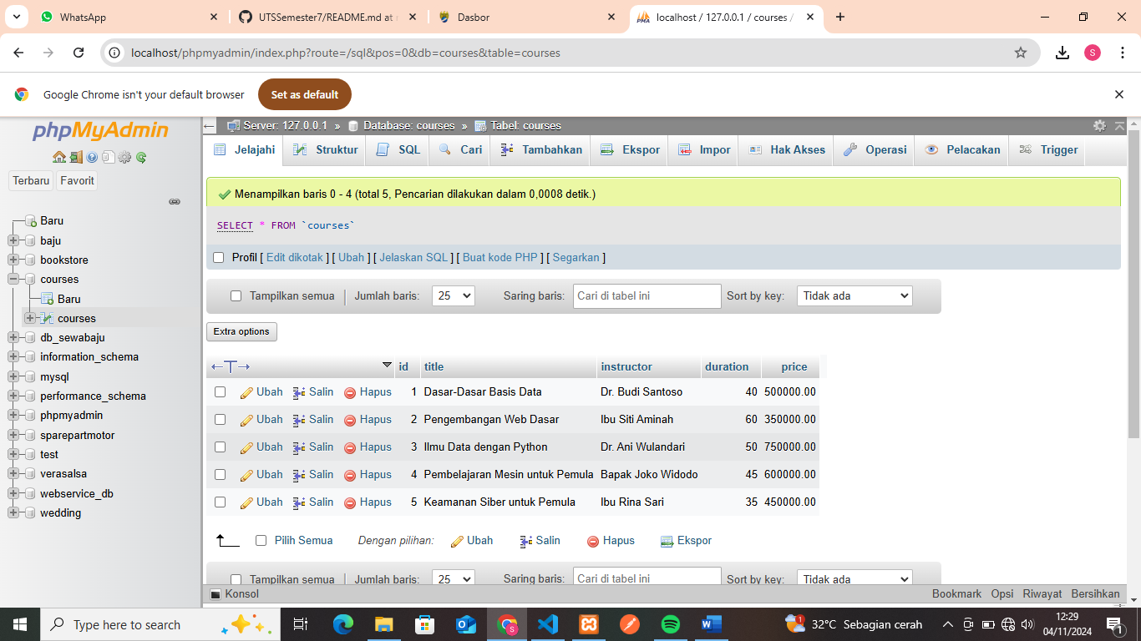

1. **Membuat File di htdocs file C**

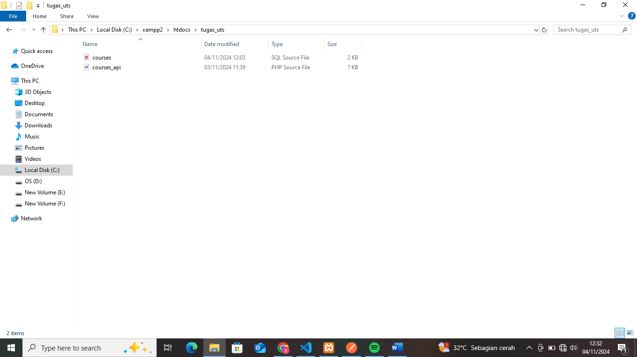

1. **Program yang ada di Courses_api.php**

<?php

header("Content-Type: application/json");

$host = 'localhost';

$db_name = 'courses';

$username = 'root';

$password = '';

$conn = new mysqli($host, $username, $password, $db_name);

if ($conn->connect_error) {

die(json_encode(["status" => "error", "message" => "Koneksi gagal: " . $conn->connect_error]));

}

$method = $_SERVER['REQUEST_METHOD'];

switch ($method) {

case 'GET':

if (isset($_GET['id'])) {

$id = intval($_GET['id']);

$query = "SELECT * FROM courses WHERE id = ?";

$stmt = $conn->prepare($query);

$stmt->bind_param("i", $id);

$stmt->execute();

$result = $stmt->get_result();

if ($result->num_rows > 0) {

$course = $result->fetch_assoc();

echo json_encode(["status" => "success", "message" => "Data ditemukan", "data" => $course]);

} else {

http_response_code(404);

echo json_encode(["status" => "error", "message" => "Data tidak ditemukan", "data" => null]);

}

$stmt->close();

} else {

$search = isset($_GET['title']) ? $_GET['title'] : '';

$query = "SELECT * FROM courses";

if ($search) {

$search = $conn->real_escape_string($search);

$query .= " WHERE title LIKE '%$search%'";

}

$result = $conn->query($query);

if ($result->num_rows > 0) {

$courses = [];

while ($row = $result->fetch_assoc()) {

$courses[] = $row;

}

echo json_encode(["status" => "success", "message" => "Data ditemukan", "data" => $courses]);

} else {

echo json_encode(["status" => "success", "message" => "Tidak ada data", "data" => []]);

}

}

break;

case 'POST':

$data = json_decode(file_get_contents("php://input"), true);

if (empty($data['title']) || empty($data['instructor']) || !isset($data['duration']) || !isset($data['price'])) {

http_response_code(400);

echo json_encode(["status" => "error", "message" => "Semua field harus diisi.", "data" => null]);

exit();

}

$title = $conn->real_escape_string($data['title']);

$instructor = $conn->real_escape_string($data['instructor']);

$duration = intval($data['duration']);

$price = floatval($data['price']);

$query = "INSERT INTO courses (title, instructor, duration, price) VALUES (?, ?, ?, ?)";

$stmt = $conn->prepare($query);

$stmt->bind_param("ssdi", $title, $instructor, $duration, $price);

if ($stmt->execute()) {

http_response_code(201);

echo json_encode(["status" => "success", "message" => "Data berhasil ditambahkan.", "data" => null]);

} else {

http_response_code(500);

echo json_encode(["status" => "error", "message" => "Gagal menambahkan data.", "data" => null]);

}

$stmt->close();

break;

case 'PUT':

if (isset($_GET['id'])) {

$id = intval($_GET['id']);

$query = "SELECT * FROM courses WHERE id = ?";

$stmt = $conn->prepare($query);

$stmt->bind_param("i", $id);

$stmt->execute();

$result = $stmt->get_result();

if ($result->num_rows > 0) {

$data = json_decode(file_get_contents("php://input"), true);

if (empty($data['title']) || empty($data['instructor']) || !isset($data['duration']) || !isset($data['price'])) {

http_response_code(400);

echo json_encode(["status" => "error", "message" => "Semua field harus diisi.", "data" => null]);

exit();

}

$title = $conn->real_escape_string($data['title']);

$instructor = $conn->real_escape_string($data['instructor']);

$duration = intval($data['duration']);

$price = floatval($data['price']);

$queryUpdate = "UPDATE courses SET title = ?, instructor = ?, duration = ?, price = ? WHERE id = ?";

$stmtUpdate = $conn->prepare($queryUpdate);

$stmtUpdate->bind_param("ssdii", $title, $instructor, $duration, $price, $id);

if ($stmtUpdate->execute()) {

http_response_code(200);

echo json_encode(["status" => "success", "message" => "Data berhasil diupdate.", "data" => null]);

} else {

http_response_code(500);

echo json_encode(["status" => "error", "message" => "Gagal mengupdate data.", "data" => null]);

}

$stmtUpdate->close();

} else {

http_response_code(404);

echo json_encode(["status" => "error", "message" => "Data tidak ditemukan", "data" => null]);

}

$stmt->close();

} else {

http_response_code(400);

echo json_encode(["status" => "error", "message" => "ID harus diisi.", "data" => null]);

}

break;

case 'DELETE':

if (isset($_GET['id'])) {

$id = intval($_GET['id']);

$queryCheck = "SELECT * FROM courses WHERE id = ?";

$stmtCheck = $conn->prepare($queryCheck);

$stmtCheck->bind_param("i", $id);

$stmtCheck->execute();

$resultCheck = $stmtCheck->get_result();

if ($resultCheck->num_rows > 0) {

$queryDelete = "DELETE FROM courses WHERE id = ?";

$stmtDelete = $conn->prepare($queryDelete);

$stmtDelete->bind_param("i", $id);

$stmtDelete->execute();

if ($stmtDelete->affected_rows > 0) {

http_response_code(200);

echo json_encode(["status" => "success", "message" => "Data Berhasil Dihapus", "data" => null]);

} else {

http_response_code(500);

echo json_encode(["status" => "error", "message" => "Gagal menghapus data.", "data" => null]);

}

$stmtDelete->close();

} else {

http_response_code(404);

echo json_encode(["status" => "error", "message" => "Data tidak ditemukan", "data" => null]);

}

$stmtCheck->close();

} else {

http_response_code(400);

echo json_encode(["status" => "error", "message" => "ID harus diisi.", "data" => null]);

}

break;

default:

http_response_code(405);

echo json_encode(["status" => "error", "message" => "Metode tidak diizinkan.", "data" => null]);

break;

}

$conn->close();

?>

1. **Pengujian Menggunakan Postman**
2. Get All Courses & Tittle
3. Menampilkan Semua Data

GET : <http://localhost/tugas_uts/courses_api.php>

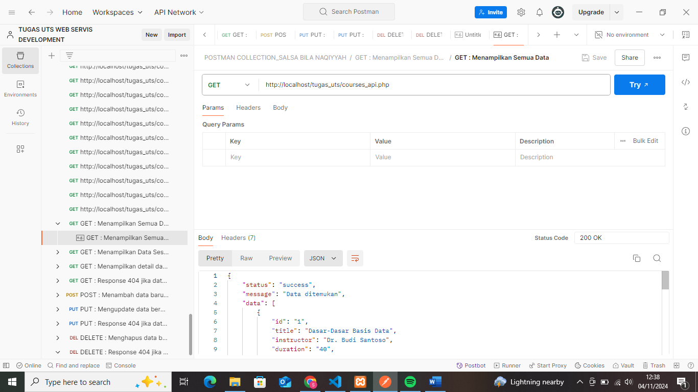

1. Mendukung Pencarian Berdasarkan Nama atau Tittle

GET : <http://localhost/tugas_uts/courses_api.php?title=Dasar-Dasar>

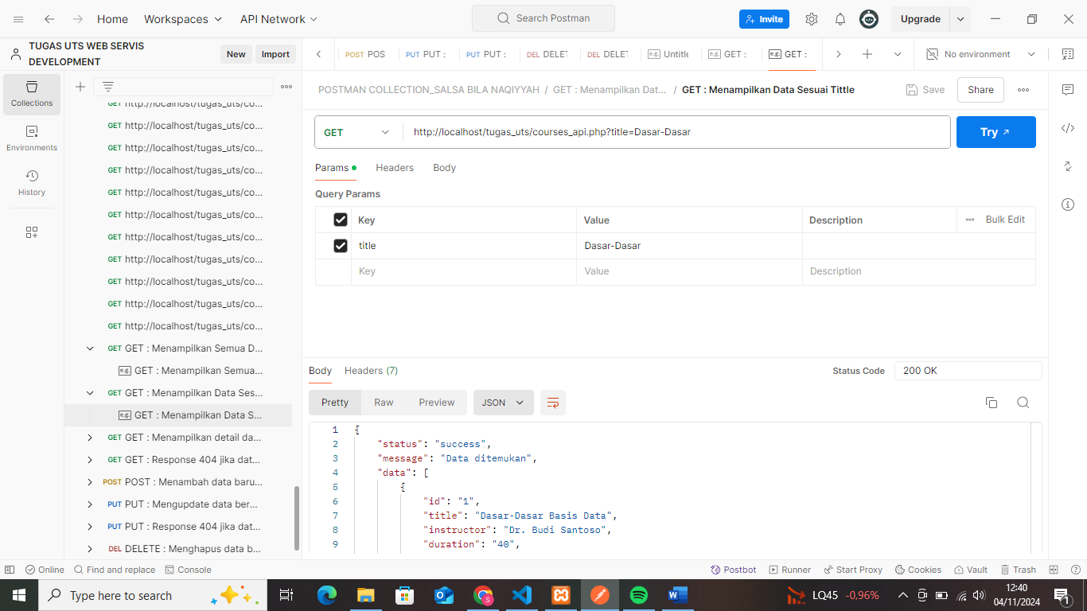

1. GET Spesific Courses
2. Menampilkan Data Berdasarkan ID

GET : <http://localhost/tugas_uts/courses_api.php?id=5>

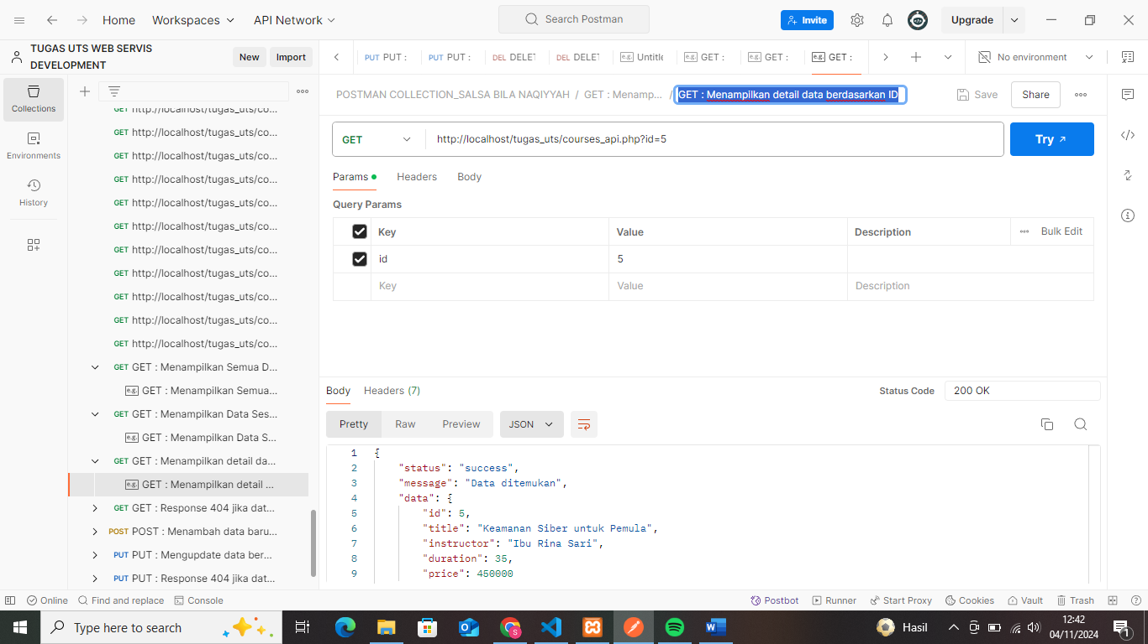

1. Response 404 Jika Data Tidak Ditemukan

GET : <http://localhost/tugas_uts/courses_api.php?id=8>

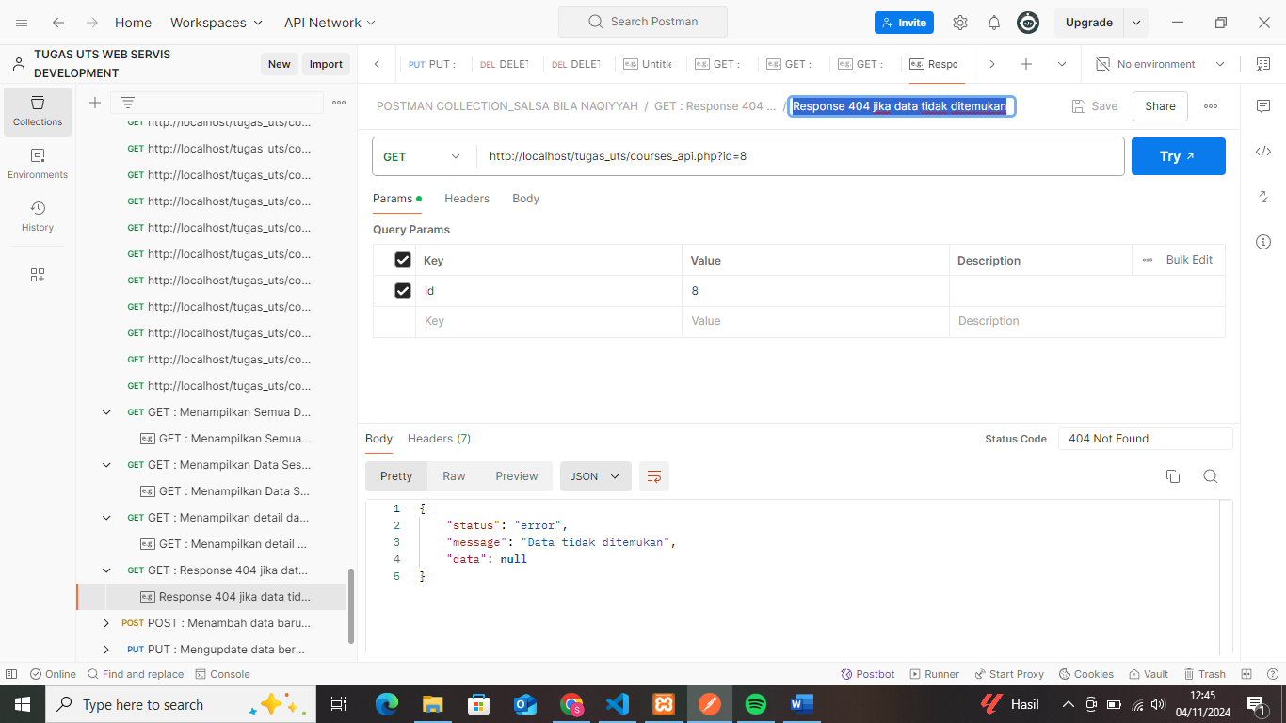

1. POST New Courses

POST : <http://localhost/tugas_uts/courses_api.php>

Masukan :

{

"id": "7",

"title": "Belajar PHP untuk Pemula",

"instructor": "Dr. Salsa Bila",

"duration": "60",

"price": "300000.00"

}

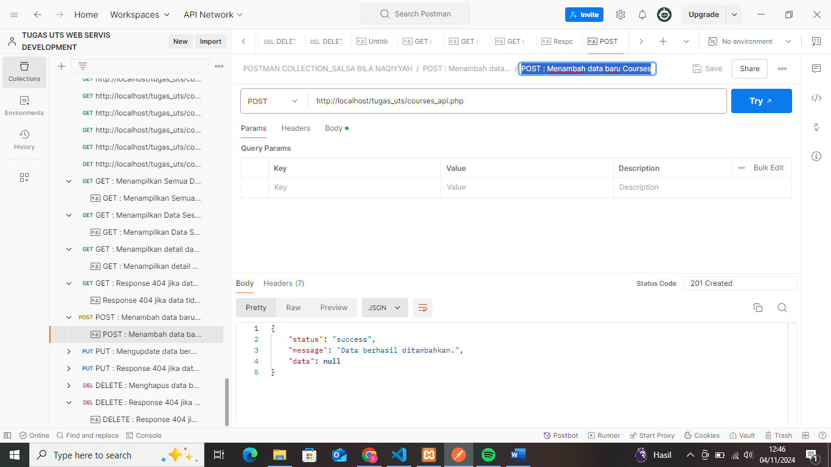

1. PUT (Update) Courses
2. Mengupdate Data Berdasarkan ID

PUT : <http://localhost/tugas_uts/courses_api.php?id=2>

Masukan :

{

"id": "2",

"title": "Pengembangan Web Dasar",

"instructor": "Ibu Siti Aminah",

"duration": "60",

"price": "350000.00"

}

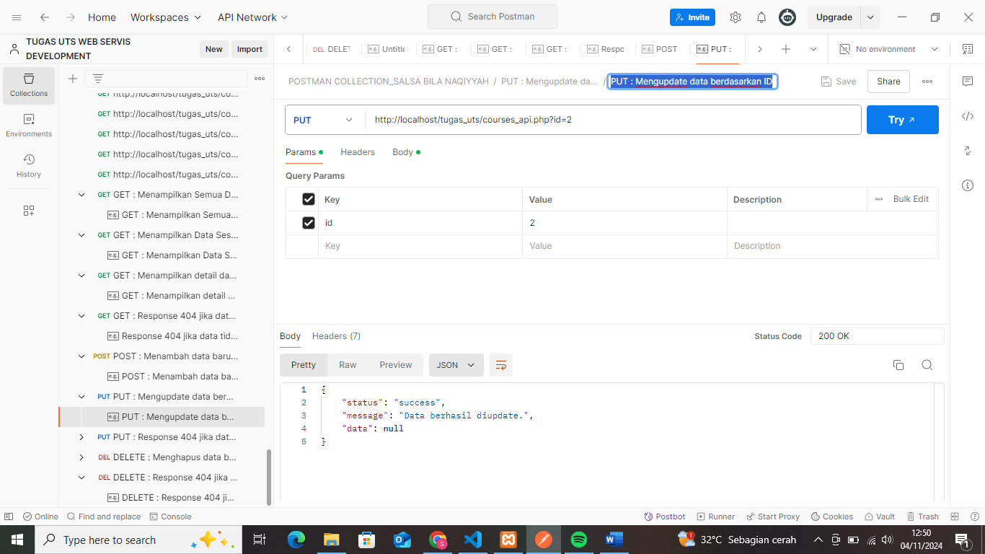

1. Response 404 Jika Data Tidak Ditemukan

PUT : <http://localhost/tugas_uts/courses_api.php?id=9>

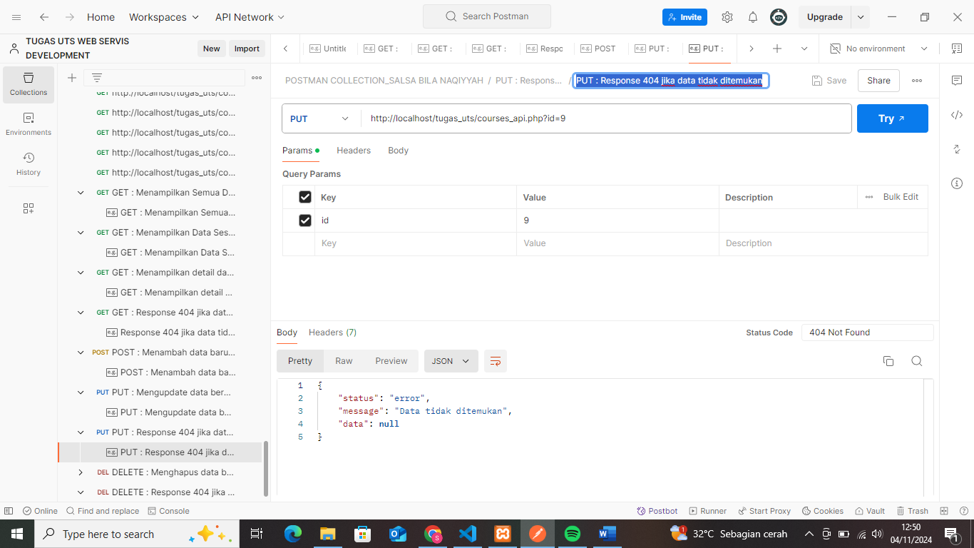

1. Delete Courses
2. Menghapus Data Berdasarkan ID

DELETE : <http://localhost/tugas_uts/courses_api.php?id=6>

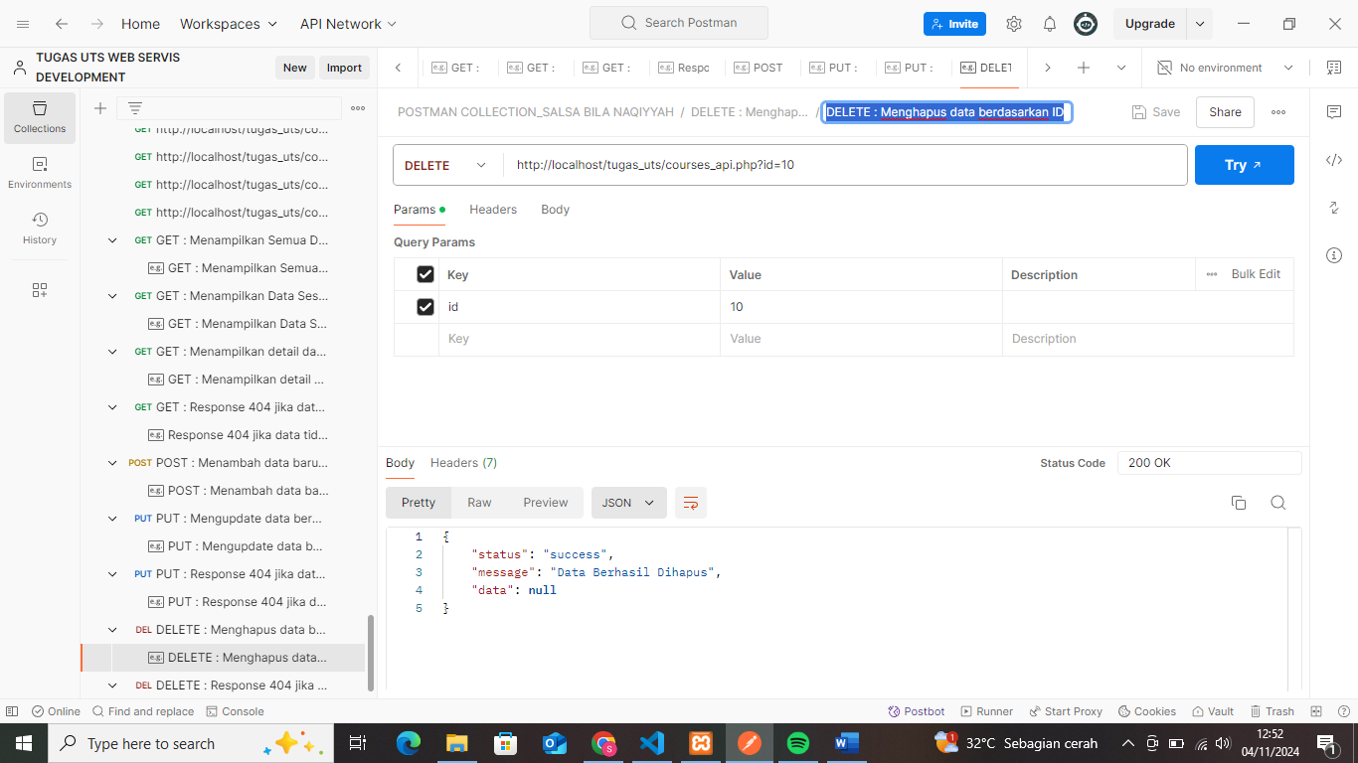

1. Response 404 Jika Data Tidak Ditemukan

DELETE : <http://localhost/tugas_uts/courses_api.php?id=10>

